VPN Connections Setup Instruction

AD User Name: abcxyz

Browse to <https://vpn.mastbazaar.com>

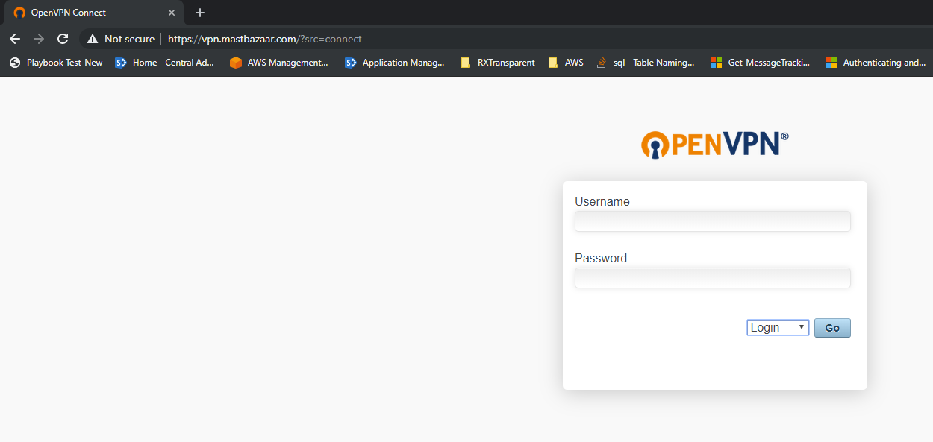

Enter the username and password, select connect in the drop down., click Go

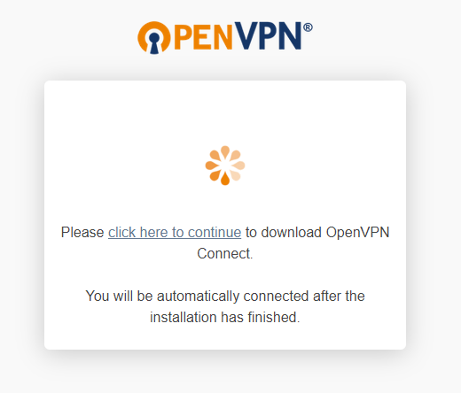

Click ‘Click her to continue’ to download the Open VPN connect – client software.

Once you have downloaded the client tool, Install the tool and once the installation is done, the screen gets refreshed.

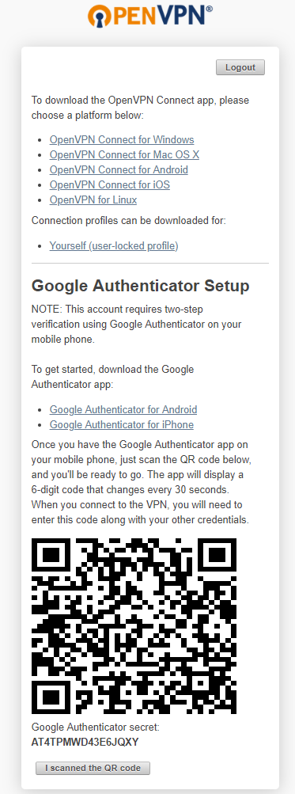

Install Google Authenticator on the mobile (Android or iOS) and add an account setup by scanning the QR code. On you have scanned the QR Code your account will be added.

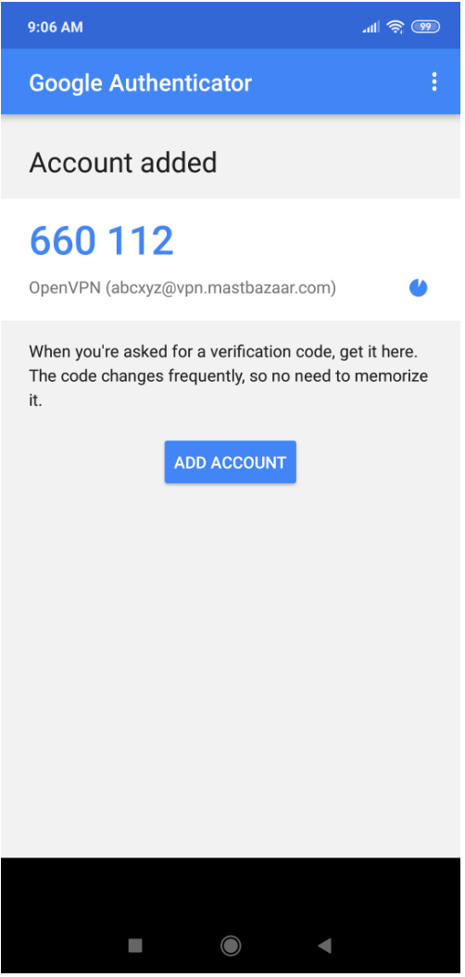

Once QR scanning done click ‘I scanned the QR Code’, the screen will get refreshed.

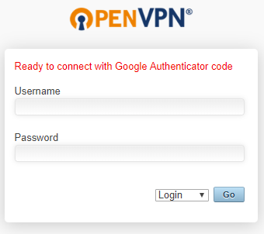

After logging in to the above screen, Download the Open VPN Client software for appropriate OS.

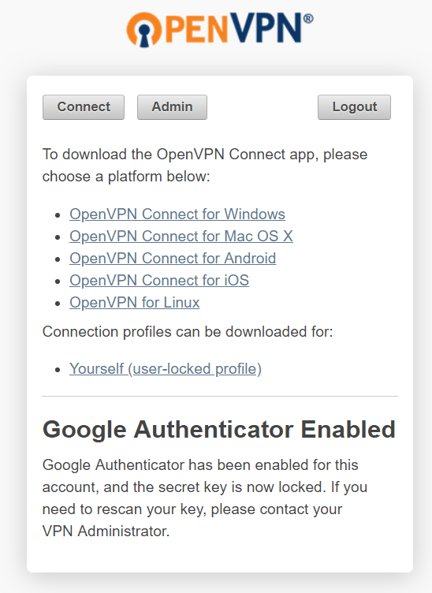

Also download the profile show in the above screen. Install the openvpn client software and import the profile file you have downloaded. Open the installed software, right click on the open vpn software icon and click connect. Then Enter the host / server name and continue, in the next screen enter the username ([abcxyz@mastbazaar.com](mailto:abcxyz@mastbazaar.com)) and password, then click connect. Finally enter the Google Authenticator Code, this code can be acquired from the Google Authenticator application on you mobile (which you have configured earlier). This code has to be entered every time when you connect to Mastbazaar VPN which is our multi factor authentication.